

USER MANUAL

Venn Diagram



GROUP 16

Abdalah Yusuf 216516718

Varuhn Ruthirakuhan - 215634140

Abdalah Yusuf -216516718

Uchechukwu Madu - 214507800

# Table of Contents

**Table of Contents: 1**

**Installation:** 3

**Getting Started:** 4

Selecting colour 8

Selecting size 9

Saving Data 10

Data Input 13

Modifying the Venn Diagram 15

# Installation:

The product application can be installed on any device that is capable of running the Java Virtual Machine through the Java Applet. The application allows the interface to interact with the specified libraries needed.

To install the Venn Diagram Application prototype, start by downloading the application from [[Venn_Diagram_Group16.jar](https://drive.google.com/open?id=1sNUFI_S4JYn1M0hpxvK0bF9BKt_qmz4-)] as a ZIP file and extract the Prototype to your directory of choice. By clicking the link you will get the pop-up as seen below where you can then click the blue button “Download” to download the file.

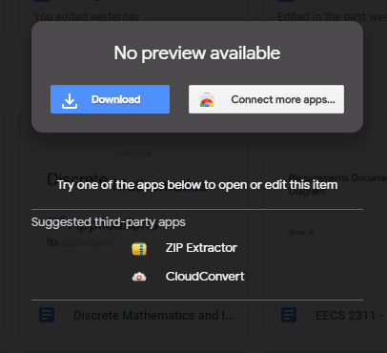

Then, to launch the application double click the .jar file.

# Getting Started:

The Venn Diagram Application can be controlled by using the prompt panel.

Below is the panel that comes up. Here is the panel where users can select the name of their topics. Then users can set their comparison topics for “First Topic”, “Second Topic”, and “Set Title” titles to then launch the application as shown below.

1. Launch Application

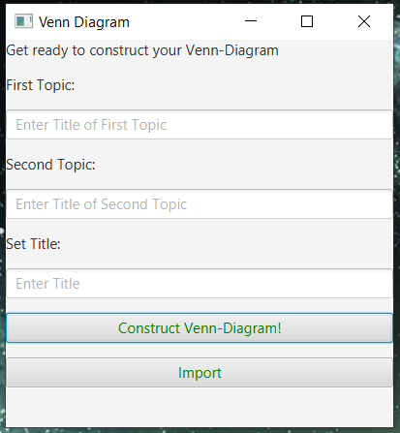

Fig 1 - First Panel

2) Select Your Topic’s name and Select your Title then click the button “Construct Venn-Diagram!”

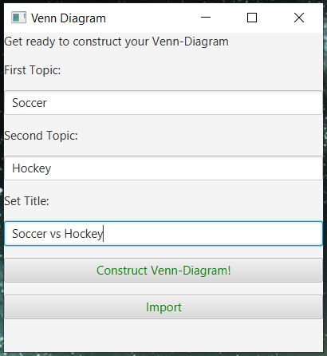

Fig 2 - First Panel with sample input

When users reach the step below, users can see their Topic 1 and Topic 2 names. Users also should be able to see their Title in the top middle of the screen. In our cases we are using Soccer vs Hockey as an example for the rest of the manual.

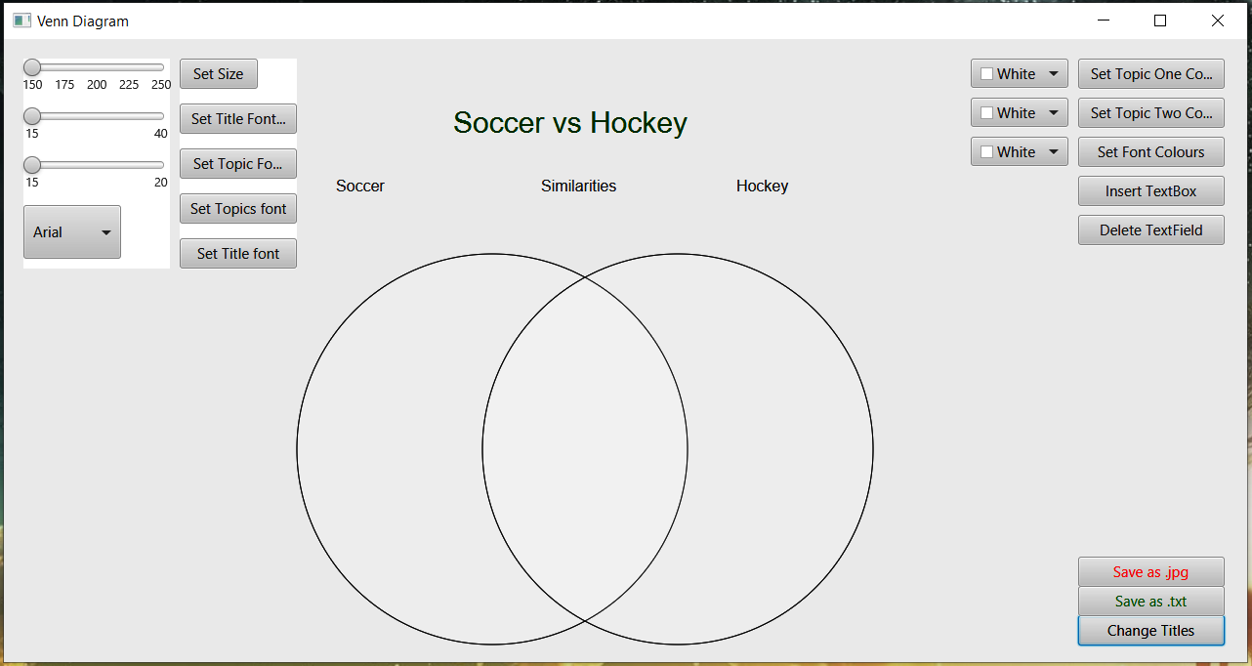

Fig 3 - Second Panel after receiving input values from Fig 2

The window above is the default Venn diagram that users will receive after selecting their topic Title. The size and colours are set to default. Users can start customizing their Venn diagram from here on. We suggest that users expand the Venn diagram to full screen mode to better suit them. Picking a slightly larger size is better suited for functionality.

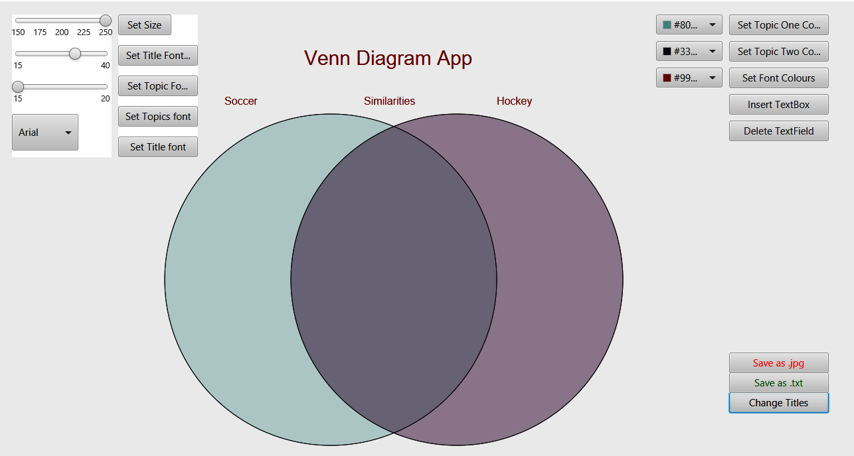

Fig 4 - After maximizing screen size.

**Selecting colour**

Users have the option of selecting a colour from the colour panel. The colour panel is located on the top right side of the screen. Users also have the choice of staying with the default colour. However, to change the colour, users can select the colour panel on the top right corner. Users can change the colour of their “Topic One” and “Topic two” and the Font colour. The complete steps are shown below.

1. Select your colour of choice for Topic one from the first slider menu.
2. Select the “Set Topic One Colour” to change the colour.
3. Select your colour of choice for Topic two from the second slider menu.
4. Select the “Set Topic Two Colour” to change the colour.
5. To change the font colour, select your colour of choice from the third slider menu
6. Select the “Set Font Colours” to change the colours for title and topics.

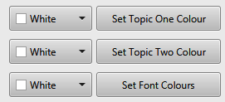

Fig 5 - Set colour options on top right of application

Users have the ability to choose from any colour of their choosing. Users will always have the ability to change the colour multiple times. Below is an example of our Venn Diagram with some random modifications.

**Selecting size**

The Venn Diagram size can be modified, by selecting the panel on the top right side of the screen. The panel has a slider for size selection ranging from 150-250 for the Venn diagram. The font sizes also range from 15-40. Through these panels, users can modify the size of the panels below. The Venn diagram size is the same for both of the circles, while the font sizes can differ, we suggest selecting the same size.

To change size, click on the slider seen in the top left corner and select the appropriate size then, click on the button “Set Size”.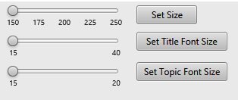

Fig 6 - Slider menu and “Set Size” button for all are seen on top left of application

For the Venn diagram users have the option of selecting their size respectively, however we recommend a slightly bigger size for better performance. They can also change the size of their Title and sub-topics font.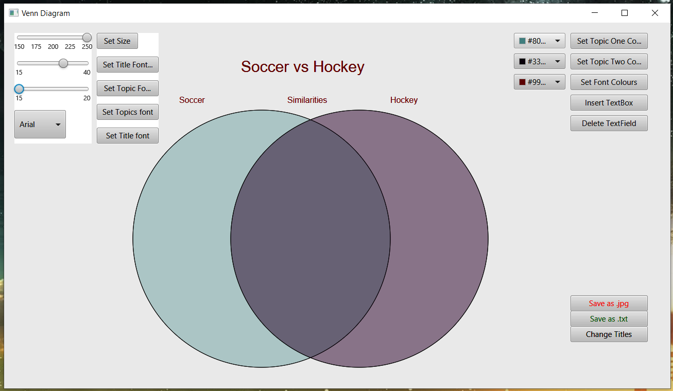

Fig 7 - Sample random colour inputs for Topic One and Topic Two and random size inputs.

**Saving Data**

Once users have inputted Data and decide to save their data, they can easily do so by clicking “ Save as .txt” or “Save as .jpeg” on the bottom right of the application. This feature allows users to save their Venn diagrams. The save as .jpeg feature makes it easy for users to see their past Diagram. The steps to saving users data as a screen shot and .txt file are shown below.

1. Click the “Save as .jpeg” or “Save as .txt” Button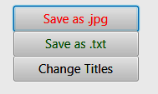

Fig 9.1- “Save as .jpeg” Button, “Save as .txt” Button and “Change Titles” Button seen on bottom right of the second panel.

1. Users must open their file explorer and search in the top right of their file explorer for the files named “Venn_Diagram.txt” and “Venn_Diagram_Screenshot.jpg”.

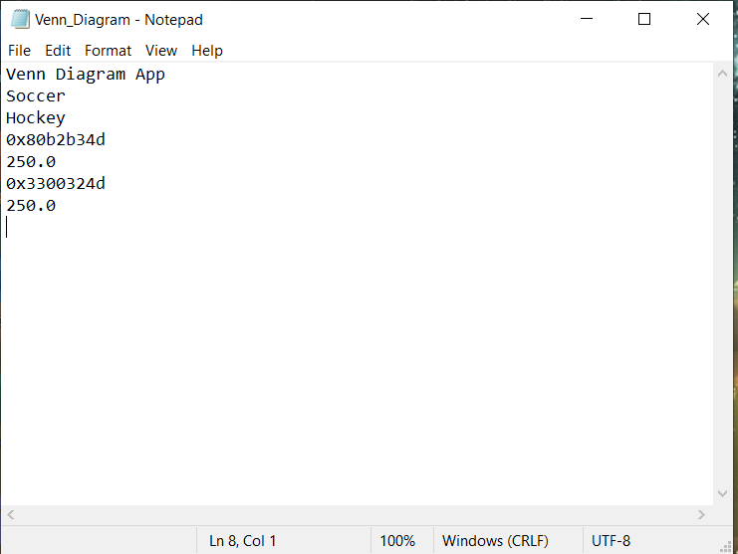

1. Fig 9.2 - Important features saved line-by-line in the “Venn_Diagram.txt” file.

## 

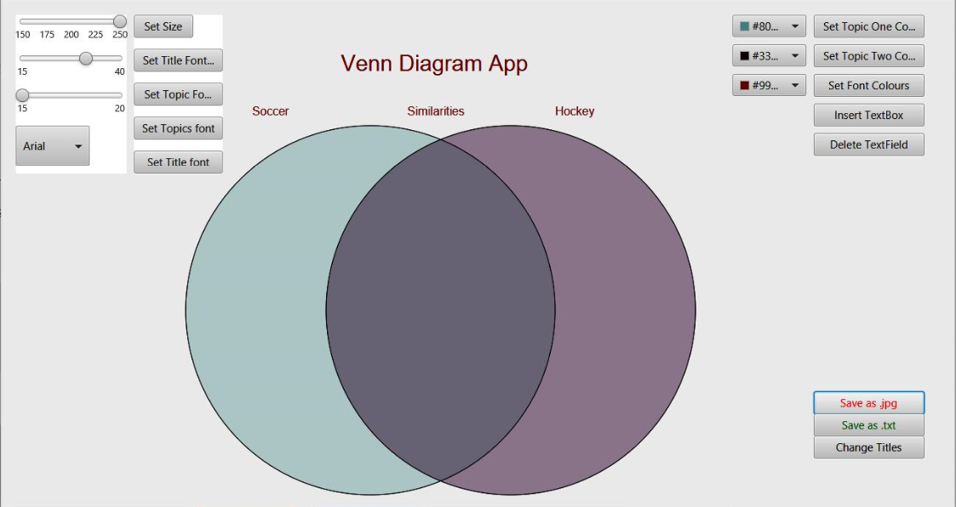

Fig 9.3- Saved Data Screen

The window can also be expanded to see the full application display.

The user can also click on the “Change Titles” button if they wish to go back to Panel 1 seen on “Figure 2” if they wish to change the title and/or topic names. Below you can see that we changed our title form “ Soccer vs Hockey” to “ Venn Diagram App” and we saved the data below. By clicking the button “Construct Venn-Diagram!” the new title will be displayed.

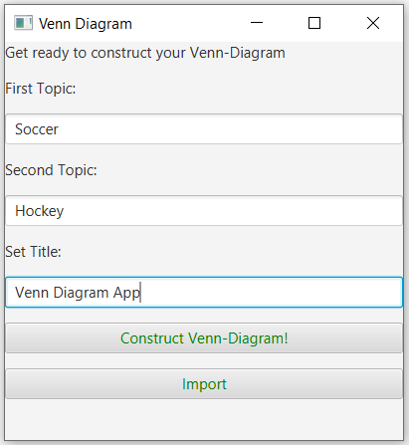

Fig 9.3- Change of titles panel

If the application is closed and later relaunched. The “Import” button can be clicked at the start of the application as seen above in figure 9.3. This button will get the previously saved data from the “Venn_Diagram.txt” file and display all the attributes on the second panel.

**Data Input**

Once users have their desired size, users can start to input data into the separate topics points and their similarities. Users can click on the button on the top right named “Insert Textbox”. This will immediately insert a draggable textbox right beside that button.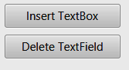

Fig - “Insert TextBox” and “Delete TextField” seen on the top right of the second panel.

After users clicks the “Insert TextBox” button and types their desired point, users can select and drag their point to the desired location. Users should know that the text boxes remain where users drop them. Users should select a size to keep the points consistent with the Venn diagram dimensions. To start, go to the text box in the top write indicated by “Enter what you want to say”. The Figures below will highlight the steps users should follow.

1. After clicking the “Insert TextBox” button the user should type what point they want into it. If the user wishes that they do not want that point, they can simply click the button “Delete TextField” to delete that text field permanently.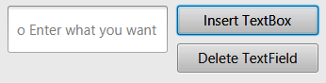

Fig - Text field that gets inserted.

1. Users can then input whatever they want into the point. The point is a draggable node so they can now drag and place the input wherever they wish whether it be inside the Venn Diagram or out.

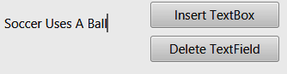

Fig - Random input from user to insert into diagram

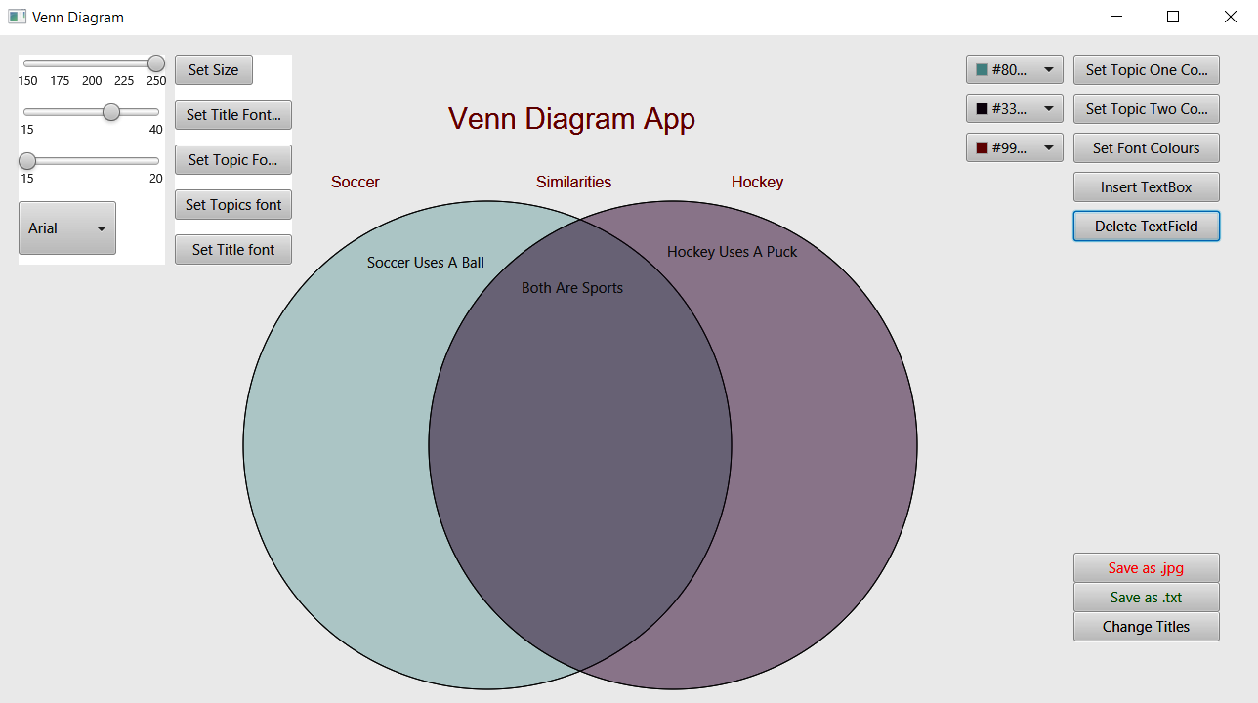

Fig - This is what the application will look like after three points are inputted into their respective locations by the user’s desire.

Users can also change the font and size of their title and sub-topics. After writing the title and sub-topics, users have the option of changing the font by selecting the drop-down menu seen on the top left side of the screen. To change the font, select the drop down menu and select your font of choice. Fonts can be selected for Topics and Title. After your Font of choice is selected select the appropriate set button to change the font. The fonts include a variety of fonts, which include; Arial, Calibri, Times New Roman, and Verdana.

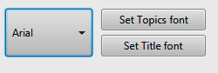

Fig 8.4- Font change for Topic and Title.

**Modifying the Venn Diagram**:

Modifying the Venn Diagram is a great way to allow users to customize their Venn Diagram experiences. Users can always change their colour and size by following the steps above. Also, users have the ability to change their title after selecting it, to a new title of their choice.